The dataset was generate by ChatGPT using my instructions in both csv and paraquet formats.

Printing Schema
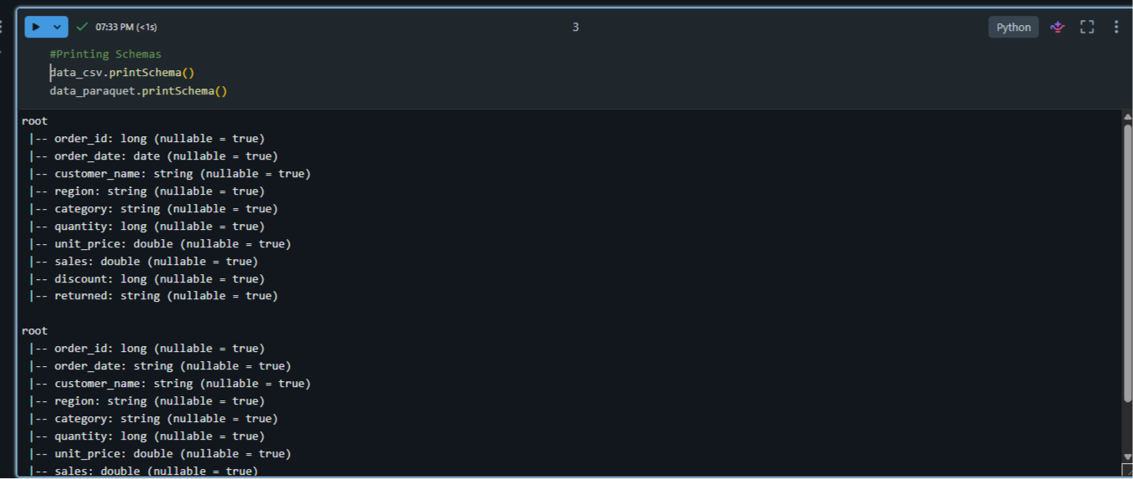
Show and Collect
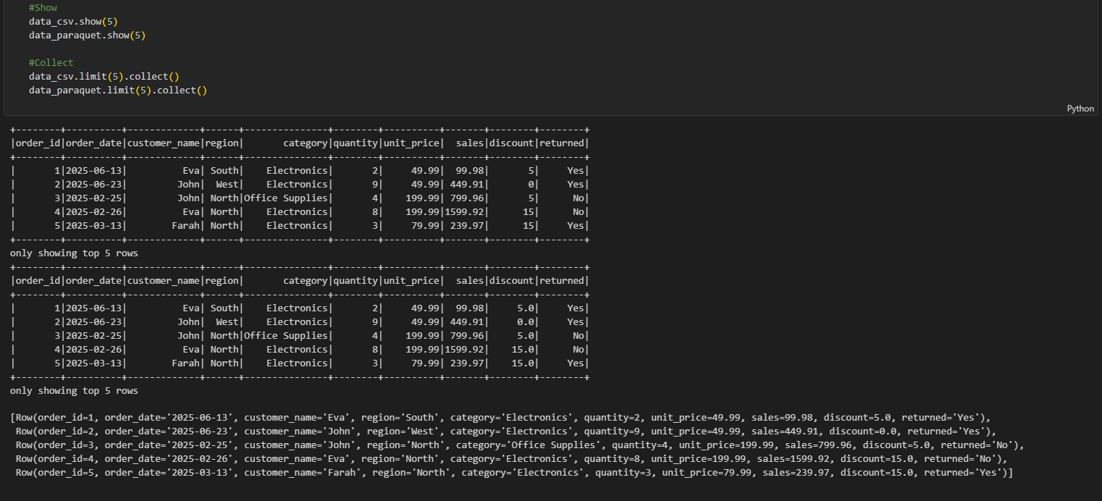

Lazy evaluation
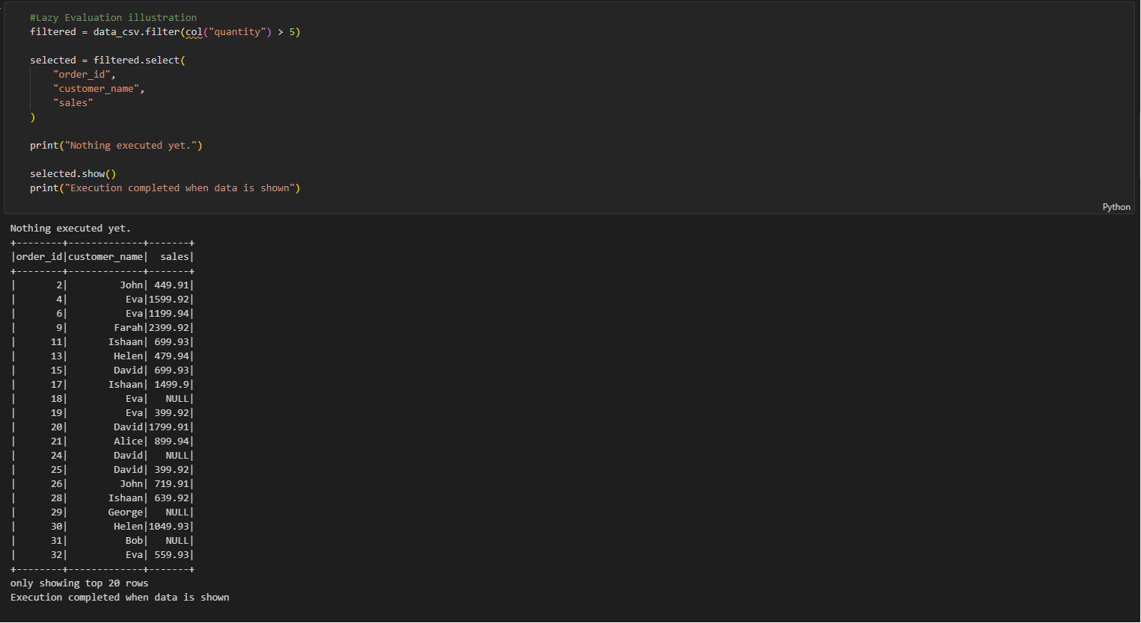
Execution plan by DAG
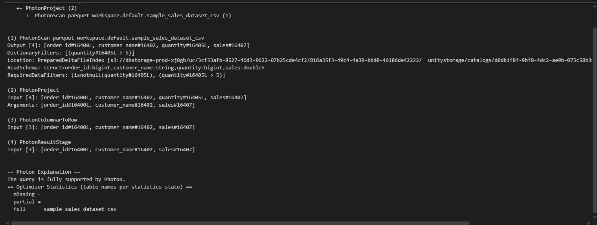

filtering and selection of required columns
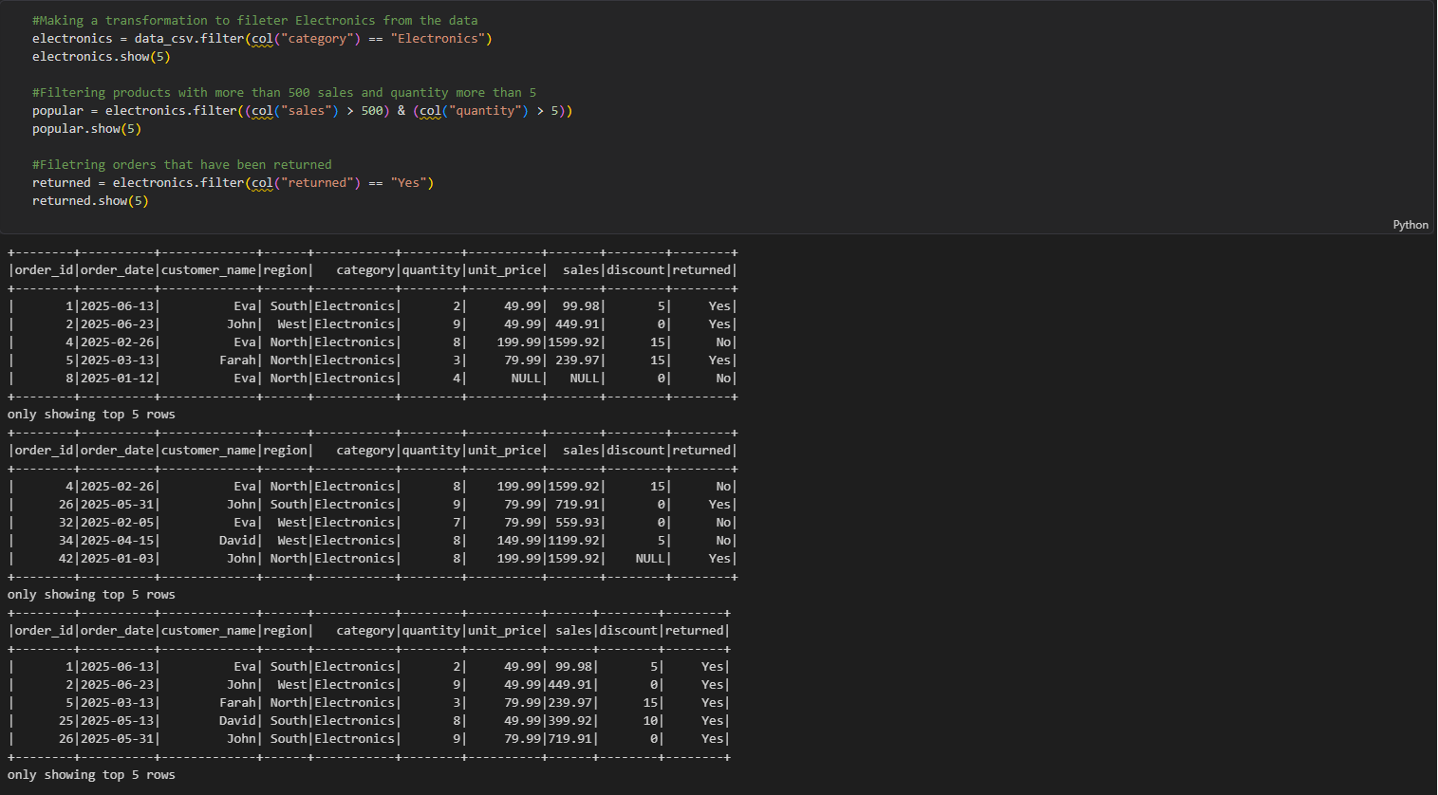
Modify DataFrames
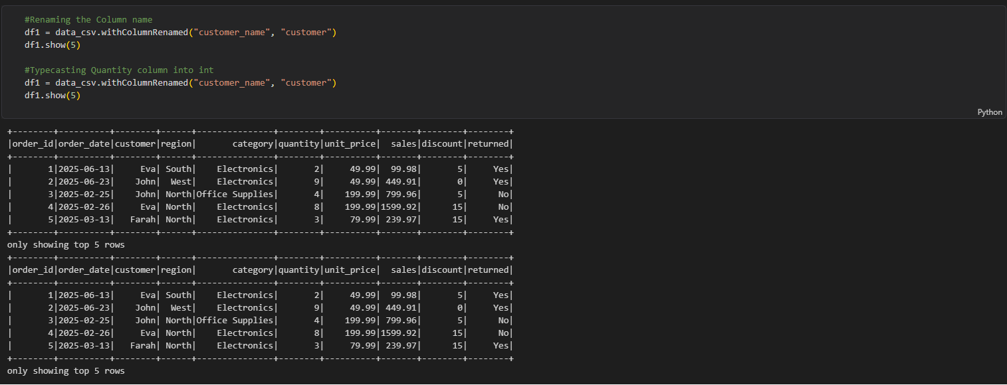

transformations and actions
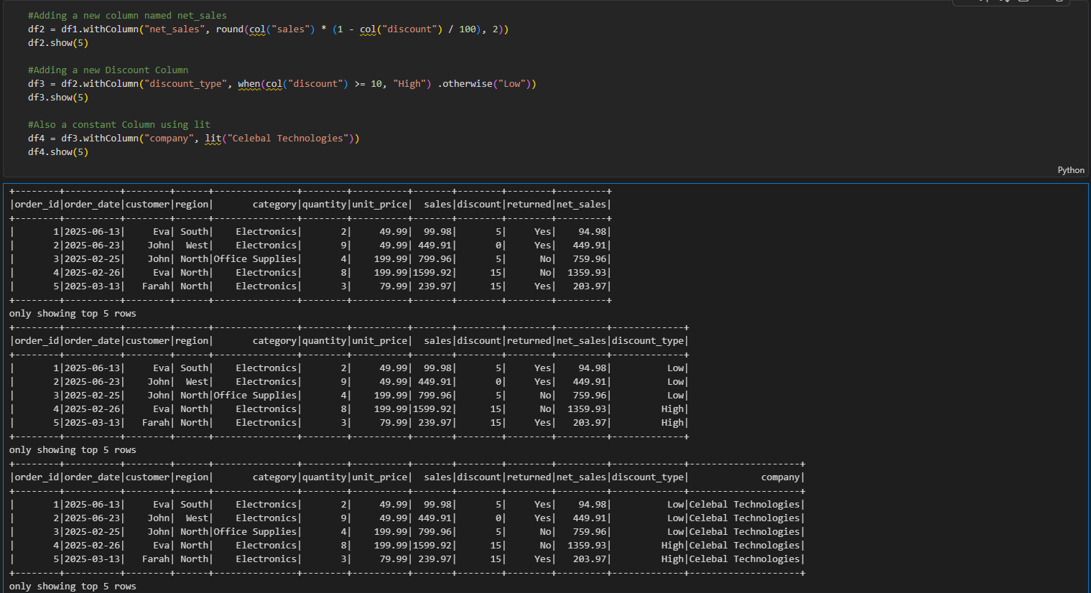

dropna and fillna
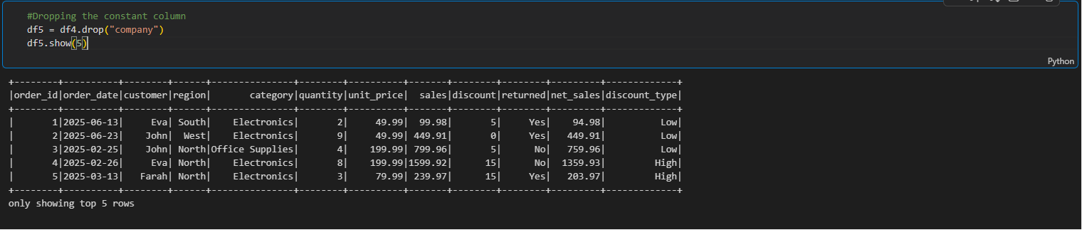
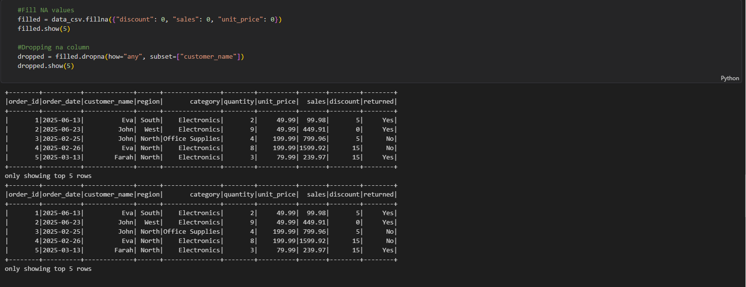

Shuffle (Wide Transformations)
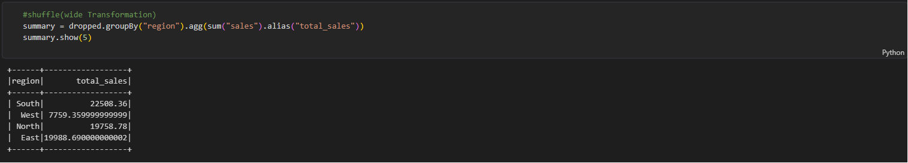
Aggregations and sorting
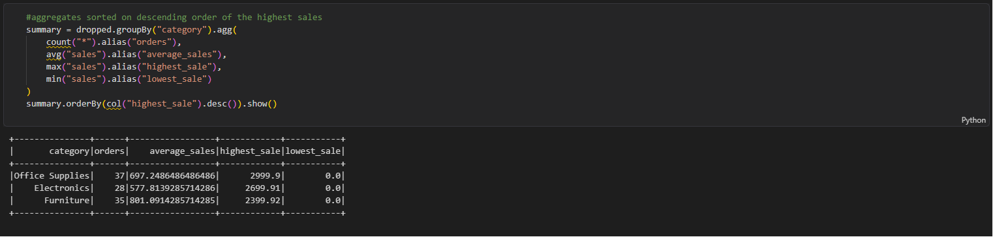
Pipeline to calculate a summary Table
